DEVELOPMENT OF AN ONLINE ELECTRICAL METER RECHARGING SYSTEM
A CASE OF KADUNA ELECTRICITY DISTRIBUTION COMPANY (KEDCO)

BY

TAHIR ALIYU
PGD/CSC/SCS/00048/2016

A PROJECT SUBMITTED TO THE DEPARTMENT OF MATHEMATICAL SCIENCE, FACULTY OF SCIENCES,
KADUNA STATE UNIVERSITY, KADUNA-NIGERIA IN PARTIAL FULFILMENT OF THE REQUEMENT FOR THE AWARD OF POSTGRADUATE DIPLOMA IN COMPUTER SCIENCE

DECEMBER, 2017

DECLARATION

I Tahir Aliyu hereby declare that this project titled (Development of an Online Electrical Meter Recharging System) has been carried out by me under the supervision of Mrs. Abdulkadir Sa’adatu. It has not been presented for award of any degree in any Institution. All sources of information are specifically acknowledged by means of reference.

TAHIR ALIYU DATE

CERTIFICATION

This dissertation by TAHIR ALIYU has made the requirement for the award of the degree of PGD computer science of the Kaduna state University, Kaduna and is approved for its contribution to knowledge.

Mrs. Abdulkadir Sa’adatu Date
Major Supervisor

Dr. Abubakar S. Magaji Date
Head of Department

Prof. John Gambo La’ah Date
Dean of Faculty

Prof. Abdullahi Musa Ashafa Date
Dean, Post Graduate School

DEDICATION

This project goes to Almighty ALLAH for His abundance grace and infinite mercy on me.

ACKNOWLEDGEMENT

I wish to forward my profound gratitude to ALMIGHTY ALLAH for his abounding grace and infinite mercy on me.
My special appreciation goes to my project supervisor, Mrs Sa’adatu Abdullahi for her untired effort, advice, encouragement and suggestion which made this project possible and also to all my lecturers in the department of mathematical science and beyond, for knowledge and skills embedded in various fields of Computer Science being impacted on me.
My special thanks also goes to my Head of Department, Dr. Abubakar S. Magaji, not forgetting the project coordinator, Dr. Hennry Samuel Dogo.
My deep thanks to my sincere friends and colleagues in persons of Aliyu Aminu (Best friend), Abbakar Kubau (Brother), Sa’adu Abdulmumin PGD (Class Rep), Auwal Ibrahim, Usman, Murtala Adamu PG, Ibrahim (the programmer), Harira Ibrahim, Sadiya Yusuf, Murja Ahmad Tahir.
To all my PGD colleagues, words alone cannot express how much I will miss you. I wish you all the best in your future endeavor Amen.
I owe my love and appreciation to my parent/guardian Alhaji Ismail Ibrahim, Alhaji Aliyu Ibrahim and my beloved mother whom no one can take her place late Zuwairah and Aishatu Aliyu for their love, advice and non-tiring assistance to me. And my sisters Aishatu, Fatimatu, Naimatu, Zaharau, Mujahidatu and my lovely brothers Rabiu, Mujaheed, Anas, Ahmad, Asmiu, Abbas and also the family of Alhaji Aminu Hunkuyi and Mr. Clement (the Oga) for their contribution in my studies. May Allah in his infinite mercy shower His blessing on you all, Ameen.

ABSTRACT

This project is designed to manage prepaid electrical meter transaction and maintenance. It is convenient and easy way for customers to recharge their prepaid meter on-line and also customer can easily send complain and picture of electrical fault such as cable cut, transformer blow, meter fault, stolen of cables etc. for immediate respond, or call engineers contact of located location. Basically, customer creates account with details such as name, address, place of employment, telephone, meter serial number etc. Same as some existing technology that sales product online after making registration with them and payment of product is taken electronically such as Jummia, aliexpress, Amazon etc. Once a customers’ account is created he/she can make payment using VISA Card, MasterCard and Verve Debit Card. A Personal Identification Number (PIN) is display to the customer through the system after the payment is made. The customer now inserts the pin numbers into the prepaid meter and gets credited. The electrical service providers, with this system minimize the cost of employment, the process of keeping customer account, inaccurate tracking information of the electric current consume by the customer, long queue during payment, security, etc.
The system of methods in the process of development are based on primary and secondary: discussions and interview of knowledgeable and experience people in the field, searching the internet for reliable information’s, review of mode of operation of the manual ways of processing of payment at KEDCO.
The computerized online meter recharge system has therefore eliminated most the problems faced by manual methods, and has greatly helped in proper accounting and record keeping of customers with little or no error. The development of this project involves the use of ASP.NET, VB.NET and SQL Server in Visual Studio 2012 environment.

TABLE OF CONTENTS
Title page….………………………………………………………………...i
DECLARATION ii
CERTIFICATION iii
DEDICATION iv
ACKNOWLEDGEMENT v
ABSTRACT vi
TABLE OF CONTENTS viii
CHAPTER ONE 1
INTRODUCTION 1
1.0 Background of The Study 1
1.1 Statement of Problem 3
1.2 Aim and Objectives of the Study 4
1.3 Scope and Limitation of the Study 4
1.4 Research Methodology 5
1.5 Project Report Organisation 5
CHAPTER TWO 7
LITERATURE REVIEW 7
2.0 Introduction 7
2.1 Review On Related System 8
2.1.1 The Meter Reading Process 12
2.2 Distinguishing Characteridtics 13
2.3 Problems of the Existing Manual System 14
2.3.1 Monitoring of Electricity Poles Is Difficult In Some Location 14
2.3.2 Poor Maintenance and Overload of Transformer 14
2.3.3 Using of Unsubstantial Cable 14
2.4.0 Incorrect Data On Average Consumption and Under Charging of Electric Bills 15
2.4.1 Meter Numbers Not Recorded 15
2.4.2 Dates of Meters Being oout of Order or Changed Not Recorded 16
2.4.3 No Control Procedure to Ensure Correctness of Data Entry of Receipts 16
2.4.4 Lack of Documentation 17
2.4.5 IT Security 17
2.6 Limitation, Methodology and Future Suggestion 17
CHAPTER THREE 19
SYSTEM ANALYSIS AND DESIGN 19
3.0 System Analysis 19
3.1 Data Gathering 19
3.2 Design Methodology 21
3.3 System Design 21
3.4 Input Specification 22
3.5 Output Specification 22
3.6.0 System Study 23
3.6.1 Input Controls 24
3.6.2 Effective Payment 24
3.6.3 Data for Each Payment Cycle 25
3.6.4 Receipt Data 26
3.6.5 System Data Flow Diagram 28
3.6.6 Data Base Schema 28
3.7 System Development 29
3.8 Overall System Flow Chart 32
3.9 Customer Datalow Diagram 33
3.9.1 Registration 33
3.9.3 Account Update 34
3.9.4 Log Out 35
3.10 Hardware & Software Requirements 35
➢ Hardware 35
➢ Software 35
CHAPTER FOUR 36
4.0 System Implementation and Documentation 36
4.1 Conversion Procedures 36
4.1.1 Conversion Method Used 36
4.1.2 Reasons for Choosing Parallel Change Over 37
4.2 Benefits of the Proposed System 37
4.3 System Implementation 37
4.4 System Conversion 37
4.5.0 System Testing 38
4.5.1 Functional Testing 38
4.5.2 Performance Testing 39
4.5.3 Home Page Appendix 1 39
4.5.4 About Page Appendix 2: 40
4.5.5 Registration Page Appendix 3: 40
4.5.6 Payment Page Appendix 4: 41
4.5.6 Payment Detail Page Appendix 5: 41
4.5.8 Customer Payment Detail Appendix 6: 42
• This page gives all information about customer’s payments. 42
4.5.9 KEDCO Address Appendix 7: 42
• Address of KEDCO and contact. 42
4.5.10 Login Page Appendix 8: 43
4.5.11 Create User Page Appendix 9: 43
• This Page is meant for Registering New Users. 43
4.5.12 Complain Page Appendix 10: 44
4.5.13 Query Page Appendix 11: 44
SUMMARY, CONCLUSION AND RECOMMENDATION 45
5.0 Summary 45
5.1 Conclusion 45
5.2 Recommendation 46
REFERENCES 47
APPENDICES 50

CHAPTER ONE

INTRODUCTION

1.0 Background of the Study
Kaduna Electrical Distribution Company (KEDCO) is providing electricity to over 150 million customers within the Country. The company is facing a lot of difficulties on the issue of receiving payments from its customers. The distinction between two fields of investigation regarding prepaid meter payment has to be made upfront. On one side the main question of electricity generation and distribution, on the other side, maintenance or the provision and supply of basic amenities in rural or urban settlements is of different concern. This categorization is a prerequisite to understand the diversity of institutions (at the international and national level).
A computerized online system of account creation, payment, support and complete customer database must be implemented if a service provider is looking to maintain high efficiencies of online payment. Providers must ensure that customer databases are updated and computerized, through robust accounting, record keeping, regular systematized checks, and payment procedures. In some cases, across the world, a geographic information system mapping can help in updating customer records and for getting a robust record of all properties and hence all potential electric meter customers. Currently such systems are almost absent for most African service providers due to insufficient automation awareness.
In some certain cases, while customer’s records may be available they may not be computerized, since customer’s records are often maintained in log books of the various operating divisions of the provider, which are then difficult to use for keeping track of payments. Providers must focus on getting a complete computer listing of the customers they serve, by mapping and updating records not only of existing customers but also of customers who have illegally connected to the power line or of people who could be connected to the power line, but are currently coping with other alternative means. Accurate data, improved Online-based record keeping and accounting are indispensable for better understanding, monitoring, and managing of cost and revenue centers, for improving revenues and hence for moving towards financial viability. An improved customer database can also generate reliable data that can inform the decision making process of the utility or service provider.
The online system should also allow the service provider to track customer records by its respective management unit (that is, by zone, ward, circle, district, and so on). It should also allow the KEDCO staff to understand, monitor, and study historical trends so that improvements can be brought about in areas that require attention. The online system should also allow for monitoring and tracking exceptions in transactions for instance, extraordinarily low or high consumption that may be genuine or may be a result of stopped or faulty meters, electric vending practices, illegal connections tapping in, among other factors. Tracking transactions exceptions will also allow for a thorough investigation for understanding the reasons behind the exception and will help in taking adequate steps for rectifying the issue. And also customer can easily interact with the electric power company by sending complain and picture of electrical fault such as Cable cut/thief, transformer fault, meter malfunction, Electrical poll damage or breaks, tempering with electrical material by non officials among others. Have a direct contact with Engineers of located location for immediate respond.

1.1 Statement of Problem
- The process of keeping customer account record without using sufficient and reliable data has resulted in less efficient transaction of customers which spur complaint from customers as result of disconnection of electric lines to customers. Sometimes it is difficult to find an account customer’s record.
- Customers bitterly complain on how the long row is formed in the process of making their payment. They wish their payments could be made from their homes without visiting the KEDCO office. The payments outlets are always filled up with people and the security issues become very fragile.
- Some problems arise sometimes due to inaccurate tracking of information in electric current consume by the customers. The difficulty and delay in accessing data manually has been causing too much delay in the preparation of customer’s report. There is a great need for Kaduna Electrical Distribution Company (KEDCO) to take great advantage of the evolution of information technology in order to ensure effective and reliable transaction system.
- Large number of customers’ consultation at the board offices, forces the board to employ more staff in order to attend to the large number of customers, which leads to an increase in cost.
- In ability of customers to have good contact with engineers of their location.
- Generating smoot relationship between customers and (KEDCO) becomes difficult.

1.2 Aim and Objectives of the Study
The aim of this work is to develop an online electrical meter transaction system and maintenance for Kaduna Electric Distribution Company.
The computerized electric meter payment and maintenance system is intended for large companies focused on the provision of long distance and international electricity service to both corporate and private customers. The online system implements a revolutionary customer service technology utilizing credit payment systems, as well as various combinations of both, introduces a flexible system of tariffs, discounts and penalties and a flexible payment system, provides enhanced support of regulatory reference information, leads to increase in the speed of processing account and payment while enhancing its reliability. The main objectives are to evaluate:
- To replace the existing manual system with computerized online system.
- To ensure proper, effective and efficient storage.
- To reduce high level of error.
- To reduce the task of dealing of so many files for recording.

1.3 Scope and Limitation of the Study
The scope of this project is to develop an online electrical meter recharging/transaction system and maintenance for Kaduna Electric Distribution Company, within the area covered by the company across Kaduna State, Nigeria.
The work is limited to Kaduna Electric Distribution Company proper transaction and maintenance system.

1.4 Methodology
The design of the new system will be achieved using Structured System Analysis and Design Methodology. The software required to design the new system includes Adobe Dreamweaver, the programming language that will be used comprises of Hypertext Mark-up Language(PHP), Java Scripts, Cascading Style Sheet and Bootstrap, the website will be tested on a local web server “Xampp” and Structured Query Language (SQL) is used for the Database design.

CHAPTER TWO

LITERATURE REVIEW

2.0 Introduction
This chapter examines the studies related to electrical maintenance technique, electronic payment and method using a centralized database. The general overview of the manual system, payment processes and its limitations was also taken into consideration. Billing is the process by which subscribers are charged according to the service rendered to them which pays according to their consumption. It is a cyclic process employed by organizations (like Water Board, NITEL) or service providers levy dues on their subscribers based on the services they receive.
The manual recharging system is a tradition of filing system which is involved in keeping customer’s records at the KEDCO. It is important to set up and maintain an effective filing system so that customer record can be stored and documented. Manual record system provides the activity of storing files in their proper place and these works more effectively when the items to be stored are not much. It works even better when there are large numbers of items to be stored (Geoffrey, 1996). The filing system can be grouped into centralized and decentralized file, but with many risks,
KEDCO budgets volumetric allotments of electricity to customers based on customer-specific characteristics and conservative resource standards are an innovative means of improving electric use efficiency. Once thought to be impractical because of technological constraints, electric budgets linked with an increasing block rate structure have been implemented successfully in more than 20 utilities. As utilities develop advanced customer information systems and geographical information systems, these rate structures are expected to be applied more broadly. Electric budget rate structures are attractive to international water agencies searching for stable revenue generation and indeed the way in which the payment is made, improved customer acceptance, increased electric use efficiency, augmented affordability of nondiscretionary customer electric consumption, and improved blackout response (Good and stone (2000).
Electrical power fault either major or minor from high tension, transformer etc. may result to lost of power to customers in that location and at time may take longer than expected before the power company rectify the problem and the affected location would be left in darkness.

2.1 Review On Related System
Computer use in Bostwana began with a Government Computer Bureau (GCB) mainframe with dumb terminals at its Head Office in 1983/1984. The main application was COBOL-based payment system. In 1986, the Corporation introduced a Novell-based Local Area Network. Then in 1991, it introduced a Wide Area Network (WAN) which was extended to Morupule Power Station and Francistown Distribution Centre. Again, in 1995, BPC acquired a new billing system from Harris Computers in Canada. This was installed in June 1996 to improve revenue collection, customer relations and decentralization of the existing billing system. Currently, Bostwana uses wireless network within Gaborone (the Country’s Capital) (Ayoku and Kgomotso, 2009). This allows it to provide customer pay points anywhere within Gaborone. The Data Control and Meter Reading Department is responsible for billing customers for monthly consumption of electricity and uses the Harris and the Consolidated Africa Technology System (CATS) for this purpose.
Botswana Electrical Corporation (BEC) began computerization in 1987. It started with ‘Mentor (Legacy) System’ for payment. This was partially manual. Meter reading books are used to indicate the history and electric consumption of plot. The shortcoming of this system was that meter readers were able to estimate consumptions without a visit to the site. In other words, it allowed falsification of meter readings. In addition, during rainy seasons, meter-reading books were always returned wet.
The use of computers and information systems (IS) in organizations is increasingly becoming a widespread phenomenon. The availability of even cheaper and more powerful personal computers has put increasing computing power into the hands of a greater number of people.
Computer use in the public sector is particularly heavy and growing (Kraemer and Dedrick, 1996). Its ability to store, retrieve and manipulate large amounts of data rapidly and cheaply has led to its widespread use in managing many clerical, accounting and service documentation functions in organizations. Some of the benefits are quite obvious (for example use of spreadsheet for financial planning, typing of documents on computers, distribution of memos through emails, keeping of records in electronic databases.) while others are less obvious, but possibly more significant in their impact. Thus, organizational investments in ITs have increased dramatically both in the developed and the developing world. Investments in computerization have particularly increased exponentially not only in the private sector but more especially in the public sector.
Almost every government and business around the world believes that computer technology is the key to the future and many have invested a lot of money in it. A survey of the government ministries and public sector organizations in Ghana (Republic of Ghana, National ICT and Plan Development Committee, 2005) for example, found all the organizations involved computerized. Comparative analysis further indicates 100% of the public sector organizations have computer systems in place; while the corresponding figure for the government ministries was also 100%. Government and businesses, no doubt, expect to see benefits and returns from their enormous investments.
These massive investments in IT were as a result of the growing recognition among economic development specialists that investment in technology can play a critical role in stimulating economic growth and productivity. For example, during the 1990s, according to (Stiroh 2001), the United States of America enjoyed remarkable upsurge as unemployment declined, inflation remained in check and labor productivity growth accelerated to rates not consistently seen since the 1960s.
A number of empirical studies have attempted to find the benefits of IT expenditure, but the results have been conflicting. Earlier studies for example, including some fairly recent ones, failed to find positive payoffs (Roach, 1988; Bailey and Gordon, 1988; Wolff, 1991; Parsons, Gotlieb, and Denny, 1993; Love man, 1994; Wolff, 2002). These studies used financial measures (using publicly or commercially available data) and failed to capture intangible costs/benefits and/or assets such as on-the-job training, improvement on employee’s human capital to estimate payoff from investment in IT.
The intangible costs/benefits, which may be considered productivity measSures, are capable of producing excess returns on investment but fail to appear as assets in the balance sheet. This may have been responsible for the lack of statistical evidence of the impact of IT on productivity. Thus, since the 1980s, the lack of statistical evidence of the impact of computer technology has been a subject of debate as a result of the growing gap between expectations of the use of computers and the realization of its benefits. This has resulted in what is known as the “productivity paradox”.
Available literature shows that most of the fairly recent studies are reporting positive payoffs from computerization. The studies, among others, include those conducted by Thatcher and Oliver (2001), Banker, Chang and Kao (2002), and Santhanam (2003). Except for a few studies which use qualitative techniques, (Adam and Wood, 1999), most of the studies use quantitative methods (for example correlation analysis, Canonical analysis, regression analysis, Cobb-Douglas production function, data envelopment analysis, business value linkage, hierarchical regression, structural equation, etc.) and various estimation techniques like ordinary least squares, two-staged least squares, generalized least squares, weighted least squares, stochastic production frontier to estimate impact; (Mukhopadhyay, 1997). Public sector study for example, considered IT impact on both process output and quality and carried out their analysis at the application level.
Basic Function: The Bulder city Nevada is a small town in southeast ofLasVegas, Performs a variety of skilled electrical work involved in the construction, maintenance, and troubleshooting of electrical equipment, electrical substations, supervisory systems, communication and traffic signal systems, street lighting systems, water and wastewater automatic control systems, and other City electrical facilities of the municipally-owned electric distribution system and the lighting and power systems in City buildings. Some positions may specialize in the maintenance of equipment located in electric substations or maintenance of electrical systems in City-owned buildings. May assist in working on the electrical distribution and transmission systems. Provides solutions for problems on all systems serviced; to plan, coordinate, lead and participate in the work assigned; and to perform a variety of technical tasks relative to assigned areas of responsibility

2.1.1 The Meter Reading Process
Except for the differences in the payment systems, payment processing in BPC and Botswana Electrical Corporation (BEC) are the same. While BPC uses Harris System and the CATS, Botswana Electrical Corporation (BEC) uses SAP. Meter readers use handheld devices. Bill/Payment processing begins after the creation of consumer accounts. Consumer data are downloaded from the computer into the handheld devices. The data is then used for meter reading. Meter readers work for 7 hours 45 minutes per day in BPC and 6 hours per day in Botswana Electrical Corporation (BEC) for 5 days a week. In both corporations, they also work for at least two weekends in a month as overtime. This is about 54 hours 15 minutes in BPC and 42 hours in Botswana Electrical Corporation (BEC) per week (inclusive of hours spent during the weekends). This is on the average, about 46 hours 30 minutes in BPC and 36 hours in Botswana Electrical Corporation (BEC) per week per month. Each meter reader is expected to record between 150 to
300meters per day, depending on the terrain and/or the routes assigned. The results are later uploaded from the handheld devices into the Route Master (RM) in the computer for bill processing for the payment to be made.
According to (Adam and Wood (1999), because it was often difficult to obtain market prices for outputs to account for differences in quality, they developed a physical measure to quantify the output of the sorting process and used standard measures for inputs (labor hours and machine hours). They measured output quality in terms of the timeliness of mail processing. In addition, they used a set of factors in their model to account for differences in input characteristics. They used the rate of absenteeism to capture the withdrawal behavior of the work force and the extent of bar-coded incoming mail as a measure of the quality of raw material. The authors employed the production function specification using the Cobb Douglas form, and the Stochastic Production Frontier (SPF) to estimate their model.
This study focuses on The African Journal measures of productivity rather than business or financial performance. Mukhopadhyay (1997) study provided the basis of the framework developed in this study. It considers both output quantity and quality. The study considers not only the level of inputs but also the characteristics of the inputs. Since the Cobb-Douglas production function has been found suitable and reliable and is widely used, the study attempts to establish its performance in the context of Botswana.
The study relies on unpublished information from the corporations’ departments, and interviews rather than the use of computer budget and/or publicly or commercially available data as the primary data source. It confines measurement of productivity to the application (utility payment) to which the computer technology is deployed based on the corporation’s computer technology investment objectives to avoid the problem of aggregation of impacts over multiple processes.
2.2 Distinguishing Characteridtics
this is skilled electrical work in the maintenance of electrical equipment at water and wastewater treatment and pumping facilities. Electrical distribution and transmission systems of the municipally-owned electrical distribution system, and the lighting and power systems in and on city facilities. Position assigned to this classification may specialize in the maintenance of equipment located in electric substations or maintenance of electric systems associated with City owned facilities.
Maintenance requirement for electrical system will vary widely, depending on the type of device, voltage ratings and the device functions. Typically, paseeive structural component, such as busbars, cable lugs, insulation system components, and other passive materials, require only cleaning and tightening (onless some physical damage has occurred such as flooding or some other kind of external damage has occurred).

2.3 Problems of the Existing Manual System

2.3.1 Monitoring of Electricity Poles Is Difficult In Some Location
Accra greater Accra Alex Nitiforo (31 march ’99 Mr), Acting Director of Ghana Standards Board (GSB) caution users of treated wood poles for overhead power supply and telecommunication lines to be on the look out for poor quality poles on the market. Poor quality poles deteriorate fast and fall within very short periods, posing danger to the public

2.3.2 Poor Maintenance and Overload of Transformer
Distribution Transformer are generally not recommended for continuous overloading, however overloading for a short duration cannot be avoided. In case of overloading the additional loss generates more heat, which effect the burning of winding insulation causing ultimate failure of the transformer.

2.3.3 Using of Unsubstantial Cable
Disobeying the rule of low in some other African country such as Nigeria lead to the flow different variety of bad product, such as electric cable. Deviating from the good conductor electric wire materials such as copper, silver and aluminum. Different unwarranted wire flowing in to the market at cheap price and less quality, they affect the movement of electron (electricity) cause the were to melt, cut and fire.

2.4.0 Incorrect Data On Average Consumption and Under Charging of Electric Bills
According to rules, in cases of electric meters that are out of order or are missing, electric bills for the first two months should be charged based on the average of the previous four months. Analysis revealed that average amount entered in the system during June 2003 to July 2006, were lesser in 2654 cases, resulting in under charging of water bills by Rs 22.39 lakh Navi Mumbai Municipal Corporation (NMMC, 2006). In the absence of the above mentioned rule being built into the system, the average amount was calculated manually and fed into the system.
Navi Mumbai Municipal Corporation (NMMC) stated that in these cases average for one day was taken into account from the previous four months’ electric consumption and accordingly, average bills were generated for the current bill period. The reply is not relevant as the business rules were not duly incorporated in the application and the data was fed manually after calculation into the system.

2.4.1 Meter Numbers Not Recorded
It is observed that entry of meter numbers to identify the electric meters installed was kept as optional. As a result, meter numbers were not available or were entered as 0 in respect of meter readings relating to 10 consumers and 741 consumers respectively. Navi Mumbai Municipal Corporation (NMMC) stated that the above mentioned cases pertained to village consumers who had not installed meters after their old meters were damaged or stolen. The reply is irrelevant as it did not pertain to the point made by audit.

2.4.2 Dates of Meters Being oout of Order or Changed Not Recorded
In cases of meters which were reported to be out of order, date from which such meters were not working and date of change of meters should have been captured in the application to calculate and levy penalty as per rule. Analysis revealed that since entry of such information had not been made mandatory, such dates were not entered in 3255 and 1524 cases respectively. Accordingly, it was not possible for Navi Mumbai Municipal Corporation (NMMC) to levy any penalty as per rule on the consumers for not getting their meters rectified. Further analysis revealed that the meters were out of order for abnormal periods of over one year (till July 2006) in respect of 275 consumers. Navi Mumbai Municipal Corporation (NMMC) stated that suitable action would be taken to fill the left out cases and meters remaining out of order for abnormal periods.

2.4.3 No Control Procedure to Ensure Correctness of Data Entry of Receipts
To ensure completeness and correctness of data relating to collection captured in the system, the same is required to be reconciled with the details of monthly receipts reported by the ward offices. It was observed that the procedure of reconciliation was not in place. There existed a difference of Rs 1.11 lakh between the database and the figures as per the department records for the year 2005-06 which was yet to be reconciled. No action was taken to reconcile the difference. This indicated incorrect or incomplete data entry into the system.

2.4.4 Lack of Documentation
There was no documentation relating to feasibility study, user requirements, programme specification, data flow charts, input requirements, processing requirements, operational requirements, data conversion and evaluation of meeting user requirements. In the absence of documentation, the various stages of system development could not be analysed. Navi Mumbai Municipal Corporation (NMMC) stated that the System Requirements Specifications (SRS) had been prepared. However, the same was not made available to audit.

2.4.5 IT Security
By enunciating an IT security policy, the organization could reasonably protect all business critical information and related information processing assets from loss, damage or abuse.

2.6 Limitation, Methodology and Future Suggestion
- Limitation
The corporation have extended research on information technology (IT) impact on productivity importation to public sector in Africa and perhaps is the first attempt to compute the impact technology on productivity improvement among government utility corporation in Africa.
- Methodology
The time series research design was used to examine changes in productivity over time, by using it to test the study of sub hypothesis. since the focus of the study was on utility corporation using some task technology e.g the handled held devices for capturing data, the selection of the corporation was respondent was purposive, this approach has been used in a number of IS studies. Olutimayin, (2002) Adewoyew (2007), reddy, etal;2008.
The data collection procedure involves numerous site visit during the period, first to get educated on the operation of the corporations and second, to collect data for the study. Data for the quantitative variables were deducted from the examination of the unpublished corporation’s records.
- Future Suggestion
The used of computer and information system (IS) in organisation in increasing becoming wide spread phenomenon. There is obviously area for more public research on investment in computerisation in Africa as the used is not yet fully understood nor studied enough to yield meaningful insight. Although, this study focus on utility bill processing feature research could be directed towards identifying productivity impact in other application (postal system inventory control etc) in Africa.

CHAPTER THREE

SYSTEM ANALYSIS AND DESIGN

3.0 System Analysis
A system development cannot be initiated without an apparent reason. It has to be initiated by the user. The user comes up with his requirement.
In the system analysis phase of the proposed system, a detailed study of the requirement for the computerization of online payment system was carried out in order to achieve the proposed system to be built upon. The processes employed are:

3.1 Data Gathering
As a project student, an attempt was made to get all the current system documents for the ‘Kaduna Electric Distribution Company’ and the whole application for billing/payment and maintenance was observed interviews with the operational, administrative, and staff to generate some data for the subsequent analysis and design. The following are the techniques used to obtain the information:
- Interview: This is the most common way of finding out about the current system and user requirement. Interview must be conducted to the right people and done with care because the content of the interview depends on who is being interviewed. In this project, staffs from relevant units like the admin, accounting, marketing, engineers, computing and the personnel officer were interviewed to get the useful information concerning the organization and billing/payment and maintenance in general.
From the relevant people interviewed and some customers being meet at queue in the KEDCO office, purchasing prepaid meter code, their respond to the interview on recharging prepaid meter online was good, they said it will save their time consuming and customer can reload his/her meter, have contact of there location engineers and send complain, accidental photo of electricity damage or tempering with at their convenient and also save risks.
- Observation: This is time consuming but provides first-hand information about how activities are carried out and it can uncover. Much information on working practices. This is very helpful because people rarely give complete details on how they do things.
Time taking is one the priority given in the development, unspecified amount of fund during the process and the comprising people idea or detail in order to provide a software at their convenient were observed.
- Research: The research is based on secondary research which is from books, computer magazines, CD ROMs, journals and internet. It takes 40% of the research approximately. Also the secondary research involved going to the school libraries such as Kashim Ibrahim Library, Mathematics Department library to obtain the relevant research information required.
Some early research (background reading), into the different types of payment was carried out, in order to gain some understanding of the features of the different types of billing system. It was conducted that creating application that would serve as the payment system would be the ideal product, which would suit the need of this task.

3.2 Design Methodology
A System or method for a unique situation, the term is most often applied to technological field in reference to web design, software or information system design and the development of software interface that suit the operations, that puzzle out the problem.

3.3 System Design
When problems are well understood, solutions can be formulated and help inform the design of the future system. The result from the analysis gives indications that the improvements in the process are needed. The preliminary investigation revealed that there was a number of things wrong with the way the task is currently being undertaken. In order to overcome these problems, there should be much more integration between the two. The problem of manual billing by different water agencies can be solved if the system to be developed is giving full support by the authority.
Based on the user requirement and the detailed analysis of a new system, the new system must be designed. The design phase of any system is very important, vital and crucial because the success of any system depends largely on its design specifications. In this phase, the final specifications are used for translating the model into a design for the proposed system. In this phase, modules are being defined showing their relationships to one another in a way known as structural chart using structured tools.
The reason for the design phase is to specify a particular software system that will meet the stated requirements gathered at the analysis phase. Structured design divides a program into smaller independent modules. They are arranged orderly in a hierarchy that shows a model of the application area which is organized in a top-down manner. The concept of modification thus comes from structured design which is an attempt to reduce complexity and makes a problem manageable by sub dividing it into smaller segments.

3.4 Input Specification
This is an interface between the user and the system that allows the user to enter data. The data input is generally done through the standard terminal keyboard, mouse or torch screen. At this stage different interface are designed to guide data entry process. Some of the input variables needed are:
- Name: the users have to input their full name which include first name, middle name and last name.
- Address: the users have to input the address of where they live.
- Phone Numbers: the users have to enter their phone numbers in case of emergency.
- Credit card numbers: the users have to give details of their credit cards.

3.5 Output Specification
This also as an interface between the user and the system that provides report to the developer. The design specification discusses the problem formulation. It identifies the kind of output expected by the user, which then guides the designer as to what to design. Therefore, for the purpose of this work, the output specification includes how to properly maintain all the vital information required and the additional features for better planning and management of the board. Also the effectiveness of the Online Recharge and maintenance System procedure is getting the entire required information effectively. The output design shows the database as it will be viewed by the user who is responsible for retrieving the information. Customers have access to the application only to log onto to send messages and obtain credit numbers by making payment through their credit card via the web application and also view some information regarding them.
Table1:
SN | USER NAME | CUSTOMER BIO-DATA | ACCOUNT/METER DETAILS | CREDIT CARD DETAILS | PIN NUMBER | REPORT
1 | Umar | -------------- | ********** | Master | ****** | --------
2 | Tahir | -------------- | ********** | Visa | ****** | ---------

3.6.0 System Study
A system maintains a master file, which contains data about different customers they rendered service to. This data is relatively static in nature and does not change periodically, the system also maintains data as follows:
- Login/Registration
- Customer Biodata
- Account/Meter Details
- Credit Card Details
- Pin Numbers
- Report

3.6.1 Input Controls
Input controls ensure that data received for processing is genuine, complete, not previously processed, and accurate, properly authorized and entered accurately and without duplication. Input controls also serve as an effective measure to detect or prevent error or fraud in a computerized system. Analysis revealed the following issues relating to lack of input controls.

3.6.2 Effective Payment
Electrical utilities and service providers in India are plagued with severe deficiencies in the delivery of services, with access to reliable, sustainable, and affordable electric supply and maintenance services remaining poor in general (WSP, 2008). The sector’s worrying performance is caused, among other reasons, by financial and capacity constraints, including the absence of a commercial orientation to services, institutional deficiencies, and the lack of systemic incentives to deliver ongoing quality services. Effective collection system is a critical component for ensuring the viability of a service provider. Improving collection activities has an immediate impact on the revenue streams of a service provider that can, in turn, help the service provider in improving services.
However, while effective collection practices depend on many internal factors (including customer databases, the extent of metered and unmetered service provision, tariff and billing structures, delivery of bills, and facilities for customer payments), the institutional arrangements under which service providers operate and provide services determine whether such practices will remain sustainable in the long term. Efficient collection practices can set incentives for the provider to effectively charge and collect electrical payment electronically while also fulfilling a commercial orientation to services.
This note draws on national and international cases to explore what it takes to implement an effective electronic collection system that encourages commercial and operational efficiencies for aiding the expansion and delivery of improved, reliable, and sustainable services. The note starts with an explanation of how poorly collection hurt the service provider, followed by the key principles of an effective billing and collection strategy, illustrated through national and international collection practices.
The various stages in the routine of Electric Billing and Collection Processes are:
• Data gathering (Meter reading in case of metered billing).
• Generation of bill based on this data.
• Distribution of bill to consumer.
• Payment of the Bill by the Consumer.
• Sending the receipt details to billing section.
• Related accounting.
Irrespective of the basis of the billing-metered/unmetered the billing system needs a database:

3.6.3 Data for Each Payment Cycle
This data will be entered for every consumer for every cycle and will be used for making the electronic payment. The required inputs are as follows:
- Card Name
- Card Number
- Expiry Date
- CCV Number

3.6.4 Receipt Data
This data will be the data related to the payments made by the consumer depending on the Amount he chose. Various data items which need to be stored are: -
Consumer number, date of receipt, receipt number, details of the payment and credit details for better administrative control over the complete payment.
In case of metered system, the number of consumers who can be handled by one-meter reader will depend upon the geographical spread of the area and other office jobs to be performed by the person. In many utilities the ranges vary from 800 to 1500 consumers per month. In case of unmetered system, the number can be increased.
The prime responsibility of meter reader/meter clerk will be to gather all the data related to the electrical connections in the given area, to collect all the data related to new connections/ disconnection or any change in the category. The electric rates/tariff structure may have one or more aspects from the following consumption based, flat rate, minimum charges, fixed charges, average consumption based etc.
Depending on the data gathered the demand for a particular billing period is calculated.
The outstanding amount is worked out on the basis of details of payments received. The charges for delayed payments or amounts not paid are calculated as per the rules. The bills are generated area-wise.
The distribution of bills can be done using any one of the following:
- By post or courier,
- By persons specially appointed for this purpose
- By concerned meter reader’s/ward clerks
- In a special round for distribution of bills,
- At the time of meter reading for the next round.
(This option saves effort/manpower but there is delay in one complete cycle in reading and distribution of bills).
The payments can be accepted at any one or more of the following:
• Counters at various offices of the Board/Corporation/Utility.
• Various branches of bank/banks authorized for accepting payments.
• Door to door/on the spot recovery by concerned person/team.
• Electronic fund transfer through various banks offering such option/directly.
• By cheque through post or drop boxes.
• Through societies authorized by government, such as cooperative societies.
• On line payments.
The collection counter/bank/person shall send the receipt details to the billing section periodically (preferably daily basis) and the same is entered into the system and the totals cross-checked. The billing section also carries out the accounting related to these receipts such as posting of receipts, generation of demand registers or ledgers on periodic basis. The complete accounting related to the payment can be more efficiently carried out by the computerized system.
The frequency of Billing governs the cash flow of the electric billing system and thus more frequency means regular cash flow. The frequency of billing depends mainly on the type of system used. For non-metered system the billing could be quarterly and for the metered system the billing could be bi-monthly. But in both cases all non-domestic, Industrial, Bulk Consumers must be billed monthly. The only other factor which can be considered in this respect is the availability of manpower for billing process and the cost of issuing bills in one complete billing cycle. Since electric is being treated as a commodity consumed the advance billing is generally not carried out. It is therefore ‘a must’ to levy penalty/interest on the delayed payments of the bills.

3.6.5 System Data Flow Diagram
Customer

User name
password
Computer based system

Transaction code
Account detail

Token
Account Update

Figure 1

3.6.6 Data Base Schema
The development of online meter recharging and maintenance system has different table which include the following:
Table2: Customers detail table: - this table contain information about customers.
FIELD NAME | DATA TYPE | FIELD SIZE
Account ID | Int | 10
First Name | String | 10
Middle Name | String | 10
Last Name | String | 10
Marital Status | String | 10
Sex | String | 7
Date of Birth | Date | 10
Place of Birth | String | 20
L.G.A | String | 10
State | String | 20
Nationality | String | 10
Next of Kin | String | 20
GSM Number | Int | 17
Meter Number | Int | 20
Address | String | 50

3.7 System Development
The Application is developed in such a way that all the operational staffs can have access to the system. The new system is composed of the following: Home
- Registration: refers to appendix 3
- Payment: refers to appendix 4
- Payment details: refers to appendix 5:
- Customers details: refers to appendix 6
- Query: refers to appendix 11
- About: refers to appendix 2:
- Complain: refers to appendix 10
- Contact address: refers to appendix 7
- Log in: refers to appendix 8:
- Create user: refers to appendix 9:
The new arrival customer should register his details and meter number as an entity of KEADCO
Home refers to appendix 1
This consists of the following:
- Information about the online meter recharge system.
- Create Customer refers to Appendix 2
- Account Number
- First Name
- Middle Name
- Last Name
- Marital Status
- Sex
- Date of Birth
- LGA
- State
- Nationality
- Next of Kin
- GSM No
- Address
- Picture
Payment refers to Appendix 3
- Card Type
- Card Name
- Card Number
- Expiry Date
- CVV Number
- Amount
- Reports refers to Appendix 7
The following consist of data about:
- Registration Report
- Payment Report
- Message refers to Appendix 11
- FAQ

3.8 Overall System Flow Chart
START

HOME
ACCOUNT
ADMINISTRATOR
CUSTOMERS
FAQ
ABOUT
CONTACT US
REPORT
CREATE USER
CUSTOMERS
REGISTRATION
PAYMENTS
PAYMENT

QUERY
LOGIN
QUENCH

STOP

Figure 2:

3.9 Customer Datalow Diagram
Registration detail
Payment
Logging out
Registration
Logout
Payment
customer

Figure 3
3.9.1 Registration
Nationality
Image
Next of kin
Customer
Customer record
Address
SN

Location

Area
Reside
Valid
Physical detail

More detail

3.9.2 PAYMENT Figure 4:
CARD
TRANSACTION AMOUNT
ACCEPT
NAME
ACCOUNT RECORD

Figure 5:

3.9.3 Account Update
Bill Payable
Check register
Pay bill
Prepare Bank payment
Update ACC Book
Amount withdraw
E. Pay
Bank withdraw
Bill detail
Check detail

Figure 6:
3.9.4 Log Out
Exit
Customer Page
Log Record
Log Detail

Figure 7

3.10 Hardware & Software Requirements

Hardware
1. Personal Computer
2. Printer
3. Internet/Network Equipment

Software
1. Microsoft Visual Studio 2010
2. SQL Server 2008
3. Windows XP, 7, 8, 10; Linux

CHAPTER FOUR

4.0 System Implementation and Documentation
Implementation Is the process of converting the old system into the newly designed and proposed system and to monitor the new system to ensure their successful operation. There are several clearly identifiable areas of activity in the implementation of the new system.

4.1 Conversion Procedures
When the new system is fully tested and proven fit for use, the next stage is to plan the implementation procedures and the changeover method to effect a drift from the old system to the newly designed online electrical meter recharging system. This can be accomplished in one of these three ways:
- Direct conversion
- Parallel Running
- Pilot Operation
Changing from existing system of operation to new method is only feasible when satisfactory results obtained during the program testing, great care and consideration should be applied during system change over to ensure that the clients will not be affected as a system down town only leads to loose in operation and profit.

4.1.1 Conversion Method Used
Parallel Running- in this case both the old (manual) and new (Online) systems are opened side by side in other to compare the results and outcomes. This is needed to watch the performance and capacities of the new system when a satisfactory result is obtained in the new system; the old system is gradually withdrawn while the new system is then fully utilized.

4.1.2 Reasons for Choosing Parallel Change Over
- Helps prevent system operational total crash or down time
- Helps in accessing customers’ reaction to the new system
- Helps check mate against errors and

4.2 Benefits of the Proposed System
The faults highlighted in the current process of payment, interaction and the stressed experience by both the accountants and the customers, could be overcome with the application of this Online Meter Recharge and maintenance System that provide many unique advantages and benefits over the manual way of cordial relations and payment.

4.3 System Implementation
The implementation stage could consist of steps that need to be taken to put the new system into operation. The main steps in the implementation are:
- System testing and acceptance testing: system testing would be conducted after the program has been tested, to ensure that the whole system functions correctly.
- Information conversion: all of the data held on the old system would be converted into the correct format for the new system.

4.4 System Conversion
The chosen method of conversion is running the new system in parallel with the old one. Under this approach if any errors occur in the processing or inability to handle certain types of tasks arising from the new system, the problem could be dealt with by falling back to the old system without loss of system. This method is the safest conversion approach and offers greater security, since it guarantees that should usage problems occur in the new system. The old system can take over. The disadvantage of this method is that it doubles operational costs.

4.5.0 System Testing
Generally, system testing is the first time that the entire system can be tested against the functional Requirement Specification (FRS) and the System Requirement Specification (SRS), these are the rules that describe the functionality that the system development and a user have agreed upon. System testing tends to be more of an investigatory testing phase, where the focus is to have almost a destructive attitude and test not only the design, but also the behavior and even the believed expectations of the untended user. System testing is intended to test up to and beyond the bounds defined in the software/hardware requirements specification(s). The list below is the testing carried out at the implementation stage.
- Functional testing
- Performance testing.

4.5.1 Functional Testing
This is a testing strategy where required functions defined by the software specification are assessed. Functional testing typically involves two steps:
The first is the identification of functions that the Application is expected to perform. The second is the creation of test data that will exercise those functions. It is important to note that the time and effort required to perform functional testing can be described by the following general rules:
For every tenfold increase in defects discovered, an additional tester must be added. So if product A had 200 defects then it would require a tasting team of at least 20.

4.5.2 Performance Testing
In software development, performance testing is testing that is performed to determine how fast some aspects of a system perform under a particular workload. Performance testing can serve different purposes. It can demonstrate that the system meets performance criteria. It can compare two systems to find which performs better. Or it can measure what parts of the system or workload cause the system to perform badly. In the diagnosis case, software engineers use tools such as profilers to measure what parts of a device or software contribute most to the poor performance or to establish throughput levels for maintained acceptable response time. It is critical to the cost performance of a new system that performance test efforts begin at the inception of the deployment.
4.5.3 Home Page Appendix 1:
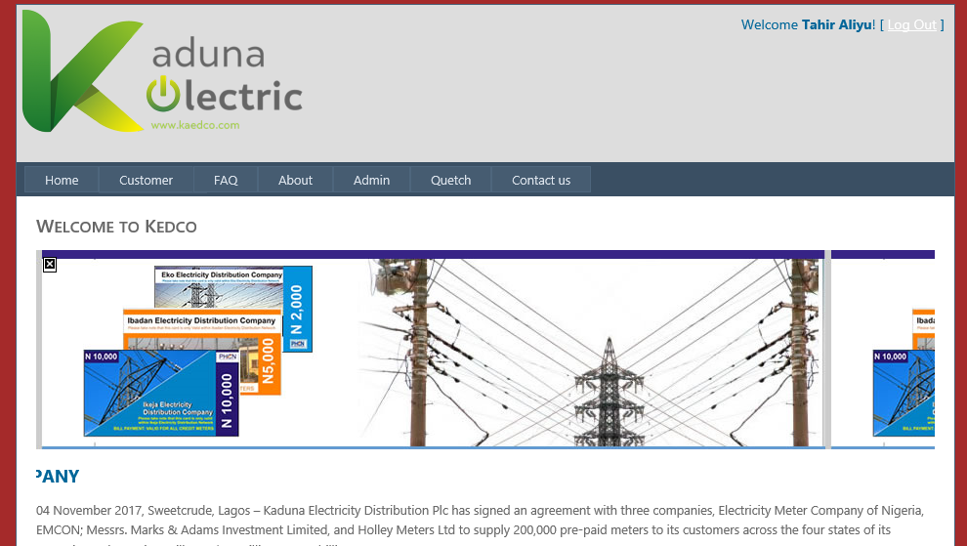

4.5.4 About Page Appendix 2:
This page consists of information about Kaduna State Electrical Distribution Company.
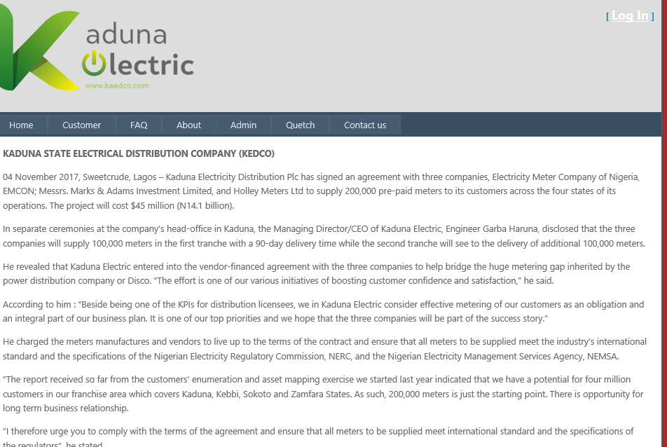

4.5.5 Registration Page Appendix 3:
This page consist of where the new user should write his information
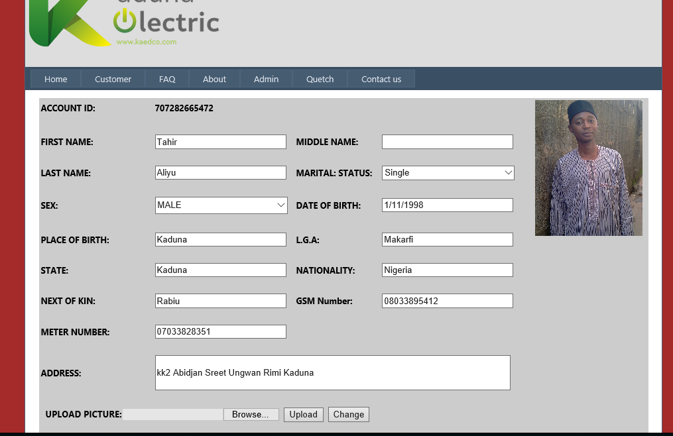

4.5.6 Payment Page Appendix 4:
- This page consists of where the user will make his payment. 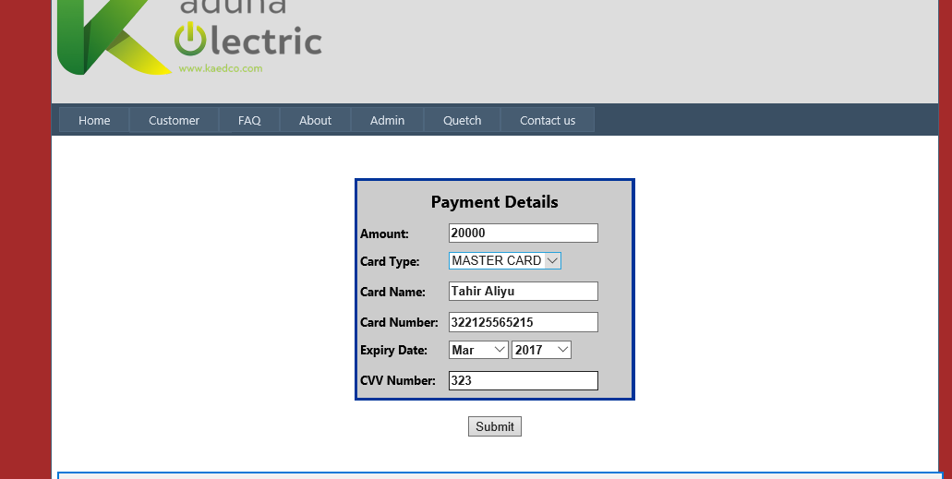
a

Payment Detail Page Appendix 5:
- This is the payment detail page.
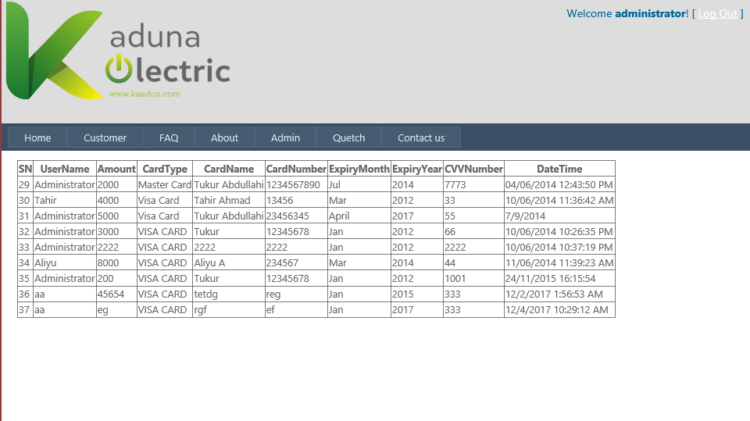

4.5.8 Customer Payment Detail Appendix 6:

This page gives all information about customer’s payments.
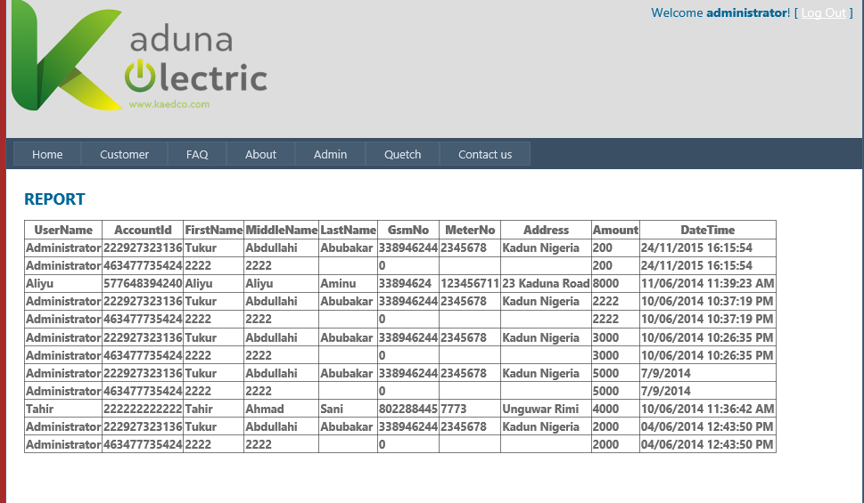

KEDCO Address Appendix 7:

Address of KEDCO and contact.
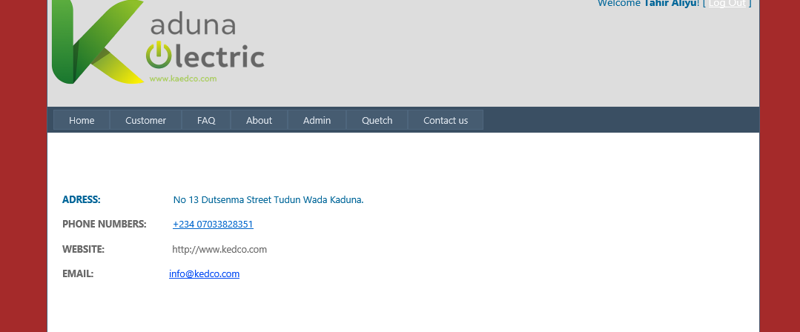

4.5.10 Login Page Appendix 8:
- This is the login page for a registered user.
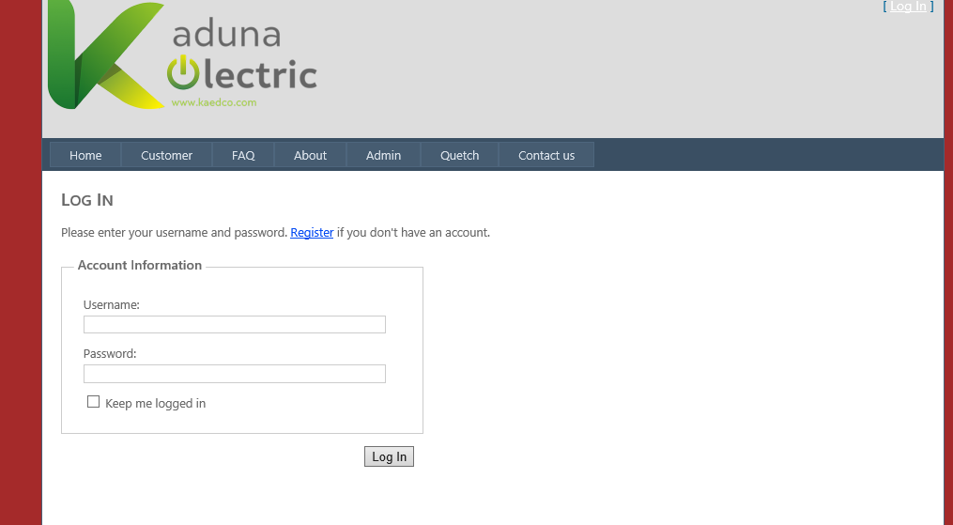

4.5.11 Create User Page Appendix 9:
- This Page is meant for Registering New Users.
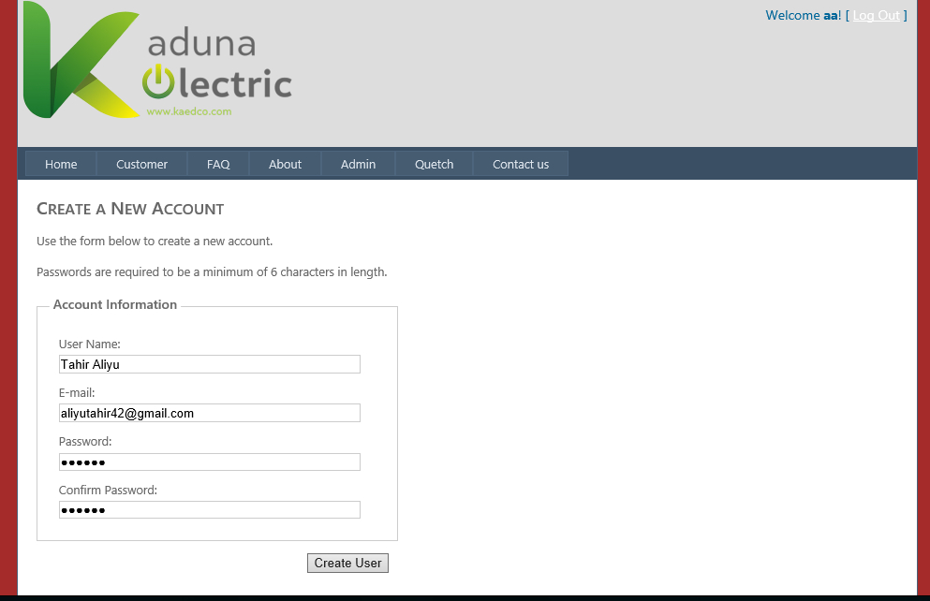

4.5.12 Complain Page Appendix 10:
This page, the message is use by customer to send direct message and pictures of fault that need to be address by the.
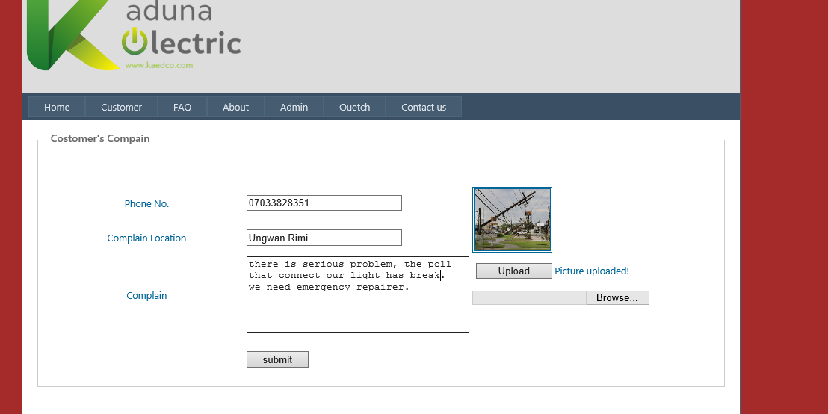

4.5.13 Query Page Appendix 11:
Complain report.
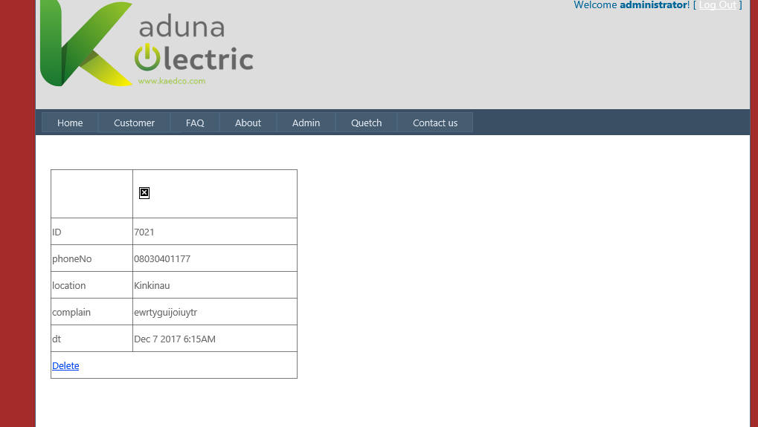

CHAPTER FIVE

SUMMARY, CONCLUSION AND RECOMMENDATION

5.0 Summary
An online meter recharge and maintenance system was developed and implemented in order to overcome the problems inherent with the manual mode of billing/payment system and respond to fault by the engineers. The system methods in the process of development are based on primary and secondary: discussions and interview of knowledgeable and experience people in the field, searching the internet for reliable information’s, review of mode of operation of the manual ways of processing of payment and maintenance at KEDCO.
The advantages of computerized approach of online recharging and maintenance system are as follows:
- Maximum and efficient storage
- Less paper work
- Online payment
- Cordial relations
- Quick response time to administrative request
- Error minimization of the lowest degree.
- Maintaining integrity.

5.1 Conclusion
This project particularly was designed to correct errors/respond encountered in using manual system to keep electric payment records and quick respond to fault, the problem was properly handled by the newly introduced computerization of online payment system as it is fast in retrieving and storing data and also utilizes the database which aids data and information security as it is not prone to disaster and misplacement
Hence the computerized online meter recharge system has therefore eliminated most problems faced by manual methods, and has greatly helped in proper accounting and record keeping of customers with little or no error.

5.2 Recommendation
Based on the findings of this project work to enhance productivity of system users and output performance the following recommendations were made:
- Developing a special mobile number or code for normal phone users. The code will enable users to enter their bank details, that will be connected to their account for easy transaction of recharging and updating the units of prepaid meter.
- Developing mobile application that will run on any operating system (OS). The application can be used for checking the balance of the units on the meter, providing deposit account profile for purchasing units using prepaid meter card (wallet) and automatic top-up of units on the prepaid meter when the existing balance of units are low (quickteller).

REFERENCES

Adam The Canberra Times (ACT: 1926 - 1995) (ACT: National Library of Australia). 2 June 1964. p. 27. Retrieved 13 August 2013.SCIENTOLOGY VENUS TRIP 'A DELUSION'.".
AFP (17 October 2013 Retrieved 29 March 2014). "Scientology's fraud conviction upheld in France". The Telegraph.
Anthony (2008) Water and Sanitation Program (WSP), “Performance Improvement Planning: Developing Effective Billing and Collection Practices” [online]http:// www.wsp.org.E.g., Minnkota Power's Load Management System, accessed [22 August 2009]
Ayoku, A. O. and Kgomotso, H. M., (2009) “The Impact of Computerization on
David granny. (r.1923). The Electrician, Volume 2.
Dianetics Hubbard (2008-08-25. Retrieved 2012-06-03) Court Order - FDA - Scientology E-meter". Scribd.com.
Eugenii Katz. "Blathy.(June 25, 2008. Retrieved 2009-08-04) People.clarkson.edu. Archived from the original on Christopher Riche Evans (1974). Cults of Unreason.
Corydon, Bent (1987). Messiah or Madman. Lyle Stuart. p. 313.
Farrar, Straus and Giroux. ISBN 0-374-13324-7. Chapter 6.
Geoffrey J.K, (1996) Fundamentals for Thinking and Action Isaac Prilleltensky.
HCO WW Staff (24 November 1963) Essential Information Every Scientologist Should Know, HCO Information Letter.
Hubbard, L. Ron (1982). Understanding the E-Meter. Bridge Publications. ISBN
0-88404-078-X.
Hubbard, L Ron. (27 May 1970) "Unreading Questions and Items". HCO Bulletin.
Hubbard, L Ron. (18 February 1961) "SOP Goals". HCO Bulletin.
Hubbard, L Ron (20 February 1970) "Floating Needles and End Phenomena". HCO Bulletin.
Janssen, Wallace (1993). "The Gadgeteers". In Stephen Barrett, MD, and William Jarvis, PhD (editors). The Health Robbers. A Close Look at Quackery in America. Prometheus Books, Buffalo NY. pp. 321–335. ISBN 0-87975-855-4.
Jehl, Francis (1941). Menlo Park Reminiscences. Kessinger Publishing. ISBN 978-0-7661-2648-0. p.841Microsoft Encarta Encyclopedia
Jon Atack(c.2013-02-02. Retrieved 2013-02-10.) Scientology Mythbusting the Tomato Photo! [online]". tonyortega.org.
Kevin J. Stiroh, 2001. "Information technology and the U.S. productivity revival
Kotzé(1972,) Hubbard Communications Office, East Grinstead, Sussex, England. Quoted in: report, The Report of the Commission of Enquiry into Scientology, Republic of South Africa. Section III, Chapter 8
Mukhopadhyay, et al (1997) Information system theory.
Müller, Tilo (2010). Dianetik und Scientology in ihrem Anspruch als Wissenschaft. GRIN Verlag. p. 32. ISBN 978-3-640-58010-1. "Mathison stated: "I decry the doings of trivial fakers, such as scientologists and the like, who glibly denounce hypnosis and then try covertly to use it in their phony systems""
Navi, M. M. C. (2006) “Audit Report (Local Bodies)”
Patent (2012-06-03) Official Scientology page on the E-meter"[online] Scientology.org.
(1890) Official gazette of the United States Office: Volume 50.
Prometheus (1993). Chapter 23, "The Gadgeteers",
[online]http://ieeexplore.ieee.org/Xplore/login.jsp?url=http%3A%2F%2Fieeexplore.ieee.org%2Fiel5%2F5308791%2F5309105%2F05309109.pdf%3Ftp%3D%26arnumber%3D5309109%26punumber%3D5308791&authDecision=-203
Ricks, G.W.D. (March 1896) This paper appears in: Electrical Engineers, Journal of the Institution of Issue Volume: 25 Issue: 120 on page(s): 57 - 77 Digital Object Identifier: 10.1049/jiee-1.1896.0005
Russell Miller (1987). "15. Visits to Heaven". Bare-Faced Messiah: The true story of L. Ron Hubbard. Key Porter Books. ISBN 1-55013-027-7.
Stig Ekelof discusses Christie's and Wheatstone's contributions (1, February 2001)"The Genesis of the Wheatstone Bridge" by, and why the bridge carries Wheatstone's name. Published in "Engineering Science and Education Journal", volume 10, no, pages 37–40.
Stephen Barrett, MD, and William Jarvis, PhD. (1995). Secrets of Scientology: The E-Meter REFERENCE:
Stephen A. Dyer (ed.) (2001). Survey of instrumentation and measurementWiley-IEEE, ISBN 0-471-39484-X, page 875.
Santhanam (2003). Information and system justification.
Sullivan, Dennis M. (c. 1923). The Electrical engineer, Volume 5.

Syed Khizar Ali Zaidi I, HuraMansroor I, Syed Rehan Ashraf I and Ahned. (2010) “Design and Implementation of Low Cost Electronic Prepaid Energy Meter” NED University of Engineering and Technology, Karachi, Pakistan.
Timothy Miller, (1995) America's Alternative Religions, ISBN 0-7914-2398-0; page 386Productivity: The Case of Two State Utility Corporations in Botswana” The African Journal of Information Systems, Volume 1, Issue 3, December 2009, ISSN 1936-0282.
Graeme Gooday(2004) The morals of measurement: accuracy, irony, and trust in late Victorian electrical practice, Cambridge University Press, ISBN 0-521-43098-4, p 232-241
Thatcher and Oliver (2001), Information and system justification.
Victoria D. (1965). Report of the Board of Inquiry into Scientology p.96 [online] http://www.cs.cmu.edu/~dst/Cowen/audit/ar14.html.
Wallace Janssen, G.D.W.Ricks(1989) "The Health Robbers",
Wood (Retrieved 2012-06-03)"How the E-Meter works, Church of Scientology International"[online]Scientology.org.
(399-1997)IEEE Recommended practice for industrial and commercial power systems analysis Standard, IEEE, ISBN 1-55937-968-5 page 47.
(March 1896) Institution of Electrical Engineers Radio Section On page(s): 57 - 77|Digital Object Identifier: 10.1049/jiee-1.1896.0005.
(23 October 2009. )"INSIDE SCIENTOLOGY REACHING FOR THE STARS". NightlineABC.
W. Bernard Carlson (2003) Innovation as a Social Process: Elihu Thomson and the Rise of General Electric. Cambridge University Press, ISBN 0-521-53312-0, pages 1 and 258.
Whyte, Adam Gowans (1930). Forty Years of Electrical Progress. London: Ernest
Benn. pp. 31,159.

APPENDICES
Site master
<%@ Master Language="VB" AutoEventWireup="false" CodeBehind="Site.master.vb" Inherits="PHCN.Site" %>

<!DOCTYPE html PUBLIC "-//W3C//DTD XHTML 1.0 Strict//EN" "http://www.w3.org/TR/xhtml1/DTD/xhtml1-strict.dtd">
<html xmlns="http://www.w3.org/1999/xhtml" xml:lang="en">
<head runat="server">
<title></title>
<link href="~/Styles/Site.css" rel="stylesheet" type="text/css" />
<asp:ContentPlaceHolder ID="HeadContent" runat="server">
</asp:ContentPlaceHolder>
<style type="text/css">
.style1
{
color: #006699;
}
</style>
</head>
<body>
<form runat="server">
<div class="page">
<div class="header" style="background-color: #DDDDDD">
<div class="loginDisplay" dir="ltr"

style="background-image: url('/Images/Kaduna-Electric-1-1.png'); height: 141px; background-repeat: no-repeat;">
<asp:LoginView ID="HeadLoginView" runat="server" EnableViewState="false">
<AnonymousTemplate>
[ <a href="~/Account/Login.aspx" ID="HeadLoginStatus" runat="server"
class="style1">Log In</a> ]
</AnonymousTemplate>
<LoggedInTemplate>
Welcome <span class="bold"><asp:LoginName ID="HeadLoginName" runat="server" /></span>!
[ <asp:LoginStatus ID="HeadLoginStatus" runat="server" LogoutAction="Redirect" LogoutText="Log Out" LogoutPageUrl="~/"/> ]
</LoggedInTemplate>
</asp:LoginView>
</div>
<div class="clear hideSkiplink">
<asp:Menu ID="NavigationMenu" runat="server" CssClass="menu" EnableViewState="false" IncludeStyleBlock="false" Orientation="Horizontal">
<Items>
<asp:MenuItem NavigateUrl="~/Default.aspx" Text="Home"/>
<asp:MenuItem Text="Customer" Value="Customer">
<asp:MenuItem Text="Registration" Value="Registration"
NavigateUrl="~/Customer/Registration.aspx"></asp:MenuItem>
<asp:MenuItem Text="Payment" Value="Payment"
NavigateUrl="~/Customer/Payment.aspx"></asp:MenuItem>
</asp:MenuItem>
<asp:MenuItem Text="FAQ" Value="FAQ" NavigateUrl="~/FAQ.aspx"></asp:MenuItem>
<asp:MenuItem NavigateUrl="~/About.aspx" Text="About"/>
<asp:MenuItem Text="Admin" Value="Admin">
<asp:MenuItem NavigateUrl="~/Admin/Report.aspx" Text="Report" Value="Report">
</asp:MenuItem>
<asp:MenuItem NavigateUrl="~/Admin/Customers.aspx" Text="Customers"
Value="Customers"></asp:MenuItem>
<asp:MenuItem NavigateUrl="~/Admin/Payments.aspx" Text="Payments"
Value="Payments"></asp:MenuItem>
<asp:MenuItem Text="Quiry" Value="Quiry" NavigateUrl="~/Admin/Quiry.aspx"></asp:MenuItem>
</asp:MenuItem>
<asp:MenuItem NavigateUrl="~/Complain.aspx" Text="Quetch" Value="Quetch">
</asp:MenuItem>
<asp:MenuItem Text="Contact us" Value="Contact us"
NavigateUrl="~/Contact-Us.aspx"></asp:MenuItem>
</Items>
</asp:Menu>
</div>
</div>
<div class="main">
<asp:ContentPlaceHolder ID="MainContent" runat="server"/>
</div>
<div class="clear">
</div>
</div>
<div class="footer">

<span style="color: rgb(105, 105, 105); font-family: 'Segoe UI', sans-serif; font-size: 13px; font-style: normal; font-variant: normal; font-weight: normal; letter-spacing: normal; line-height: 14px; orphans: auto; text-align: center; text-indent: 0px; text-transform: none; white-space: normal; widows: auto; word-spacing: 0px; -webkit-text-stroke-width: 0px; background-color: rgb(182, 183, 188);">
&nbsp;</span><span
style="color: rgb(105, 105, 105); font-family: 'Segoe UI', sans-serif; font-size: 13px; font-style: normal; font-variant: normal; font-weight: normal; letter-spacing: normal; line-height: 14px; orphans: auto; text-align: center; text-indent: 0px; text-transform: none; white-space: normal; widows: auto; word-spacing: 0px; -webkit-text-stroke-width: 0px; background-color: rgb(182, 183, 188); display: inline !important; float: none;">Copyright
© 2015<span class="Apple-converted-space">&nbsp;</span></span><span
style="color: rgb(105, 105, 105); font-family: 'Segoe UI', sans-serif; font-size: 13px; font-style: normal; font-variant: normal; font-weight: normal; letter-spacing: normal; line-height: 14px; orphans: auto; text-align: center; text-indent: 0px; text-transform: none; white-space: normal; widows: auto; word-spacing: 0px; -webkit-text-stroke-width: 0px; background-color: rgb(182, 183, 188);">&nbsp;</span><span
style="color: rgb(105, 105, 105); font-family: 'Segoe UI', sans-serif; font-size: 13px; font-style: normal; font-variant: normal; font-weight: normal; letter-spacing: normal; line-height: 14px; orphans: auto; text-align: center; text-indent: 0px; text-transform: none; white-space: normal; widows: auto; word-spacing: 0px; -webkit-text-stroke-width: 0px; background-color: rgb(182, 183, 188); display: inline !important; float: none;">|&nbsp;
All Rights Reserved&nbsp; |&nbsp; PHCN.</span></div>
</form>
</body>
</html>

Complain
<%@ Master Language="VB" AutoEventWireup="false" CodeBehind="Site.master.vb" Inherits="PHCN.Site" %>

<!DOCTYPE html PUBLIC "-//W3C//DTD XHTML 1.0 Strict//EN" "http://www.w3.org/TR/xhtml1/DTD/xhtml1-strict.dtd">
<html xmlns="http://www.w3.org/1999/xhtml" xml:lang="en">
<head id="Head1" runat="server">
<title></title>
<link href="~/Styles/Site.css" rel="stylesheet" type="text/css" />
<asp:ContentPlaceHolder ID="HeadContent" runat="server">
</asp:ContentPlaceHolder>
<style type="text/css">
.style1
{
color: #006699;
}
</style>
</head>
<body>
<form id="Form1" runat="server">
<div class="page">
<div class="header" style="background-color: #DDDDDD">
<div class="loginDisplay" dir="ltr"

style="background-image: url('/Images/Kaduna-Electric-1-1.png'); height: 141px; background-repeat: no-repeat;">
<asp:LoginView ID="HeadLoginView" runat="server" EnableViewState="false">
<AnonymousTemplate>
[ <a href="~/Account/Login.aspx" ID="HeadLoginStatus" runat="server"
class="style1">Log In</a> ]
</AnonymousTemplate>
<LoggedInTemplate>
Welcome <span class="bold"><asp:LoginName ID="HeadLoginName" runat="server" /></span>!
[ <asp:LoginStatus ID="HeadLoginStatus" runat="server" LogoutAction="Redirect" LogoutText="Log Out" LogoutPageUrl="~/"/> ]
</LoggedInTemplate>
</asp:LoginView>
</div>
<div class="clear hideSkiplink">
<asp:Menu ID="NavigationMenu" runat="server" CssClass="menu" EnableViewState="false" IncludeStyleBlock="false" Orientation="Horizontal">
<Items>
<asp:MenuItem NavigateUrl="~/Default.aspx" Text="Home"/>
<asp:MenuItem Text="Customer" Value="Customer">
<asp:MenuItem Text="Registration" Value="Registration"
NavigateUrl="~/Customer/Registration.aspx"></asp:MenuItem>
<asp:MenuItem Text="Payment" Value="Payment"
NavigateUrl="~/Customer/Payment.aspx"></asp:MenuItem>
</asp:MenuItem>
<asp:MenuItem Text="FAQ" Value="FAQ" NavigateUrl="~/FAQ.aspx"></asp:MenuItem>
<asp:MenuItem NavigateUrl="~/About.aspx" Text="About"/>
<asp:MenuItem Text="Admin" Value="Admin">
<asp:MenuItem NavigateUrl="~/Admin/Report.aspx" Text="Report" Value="Report">
</asp:MenuItem>
<asp:MenuItem NavigateUrl="~/Admin/Customers.aspx" Text="Customers"
Value="Customers"></asp:MenuItem>
<asp:MenuItem NavigateUrl="~/Admin/Payments.aspx" Text="Payments"
Value="Payments"></asp:MenuItem>
<asp:MenuItem Text="Quiry" Value="Quiry" NavigateUrl="~/Admin/Quiry.aspx"></asp:MenuItem>
</asp:MenuItem>
<asp:MenuItem NavigateUrl="~/Complain.aspx" Text="Quetch" Value="Quetch">
</asp:MenuItem>
<asp:MenuItem Text="Contact us" Value="Contact us"
NavigateUrl="~/Contact-Us.aspx"></asp:MenuItem>
</Items>
</asp:Menu>
</div>
</div>
<div class="main">
<asp:ContentPlaceHolder ID="MainContent" runat="server"/>
</div>
<div class="clear">
</div>
</div>
<div class="footer">

<span style="color: rgb(105, 105, 105); font-family: 'Segoe UI', sans-serif; font-size: 13px; font-style: normal; font-variant: normal; font-weight: normal; letter-spacing: normal; line-height: 14px; orphans: auto; text-align: center; text-indent: 0px; text-transform: none; white-space: normal; widows: auto; word-spacing: 0px; -webkit-text-stroke-width: 0px; background-color: rgb(182, 183, 188);">
&nbsp;</span><span
style="color: rgb(105, 105, 105); font-family: 'Segoe UI', sans-serif; font-size: 13px; font-style: normal; font-variant: normal; font-weight: normal; letter-spacing: normal; line-height: 14px; orphans: auto; text-align: center; text-indent: 0px; text-transform: none; white-space: normal; widows: auto; word-spacing: 0px; -webkit-text-stroke-width: 0px; background-color: rgb(182, 183, 188); display: inline !important; float: none;">Copyright
© 2015<span class="Apple-converted-space">&nbsp;</span></span><span
style="color: rgb(105, 105, 105); font-family: 'Segoe UI', sans-serif; font-size: 13px; font-style: normal; font-variant: normal; font-weight: normal; letter-spacing: normal; line-height: 14px; orphans: auto; text-align: center; text-indent: 0px; text-transform: none; white-space: normal; widows: auto; word-spacing: 0px; -webkit-text-stroke-width: 0px; background-color: rgb(182, 183, 188);">&nbsp;</span><span
style="color: rgb(105, 105, 105); font-family: 'Segoe UI', sans-serif; font-size: 13px; font-style: normal; font-variant: normal; font-weight: normal; letter-spacing: normal; line-height: 14px; orphans: auto; text-align: center; text-indent: 0px; text-transform: none; white-space: normal; widows: auto; word-spacing: 0px; -webkit-text-stroke-width: 0px; background-color: rgb(182, 183, 188); display: inline !important; float: none;">|&nbsp;
All Rights Reserved&nbsp; |&nbsp; PHCN.</span></div>
</form>
</body> </html>

